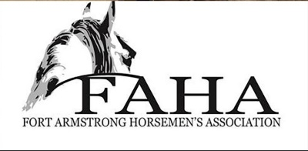
FAHA Fun Show May 16, 2021
@ Crooked Creek Horse Park
467 Crooked Creek Dam Road, Ford City, PA 16226
Starts at 10:00am - ?
Registration for Classes 8:30am – 12:00 pm
Age divisions – PeeWee 10 & under, Youth 11-18, Adult 19- 39, and Master over 40
Ribbons/ Prizes for top 5

1. Bobble Barrels
2. Dolly Down and Back
3. Pleasure Pairs (team)
4. Don’t Spill the water
*Cakewalk*
*Water Balloon Dodge Ball*
5. Egg and Spoon
6. Musical chairs on horse back
7. Relay Race (team)
8. Bobble Pole
9. Scudaho
*Classes will be ran in age consecutive order *
Class Prices: $5.00 FAHA member, $7.00 Non-member

Show will be held weather permitting
Online registration will be available on our website www.crookedcreekhorsepark.com
once we determine extended forecast

May 15th Mountain Trail Challenge (See Separate Showbill)
Come ride and stay for the weekend

