2021 FAHA Summer Series Awards
Select your desired award based on the points you earned this season.
Fill out this form and email to: atronzo@hotmail.com or text picture to (724) 496 – 2114 by September 10,2021. If your choices are not turned in you will receive a check for your point value.
Participant Name: _________________________________________________________________________
TOTAL NUMBER OF POINTS EARNED: ________
Select your Award | Award | Personalization  (if you choose) | Total  Points  Used
☐Cash in points For a Check | Check
Any Amount | GIFT CERTIFICATE: OBSESSIVE APPAREL BOUTIQUE
Any Amount | GIFT CERTIFICATE:  SPRINGHOUSE TACK
☐3 points Choose an item.  Select Quantity Tail Bags | 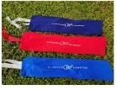
☐3 points Choose an item.  Select Quantity Basic Body Brush | 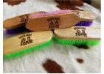
☐3 points Choose an item.  Select Quantity Face Brush | 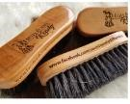
☐5 points Choose an item.  Select Quantity Mini Cutting  Board | 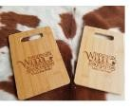
☐5 points Choose an item.  Select Quantity 8 qt  Bucket | 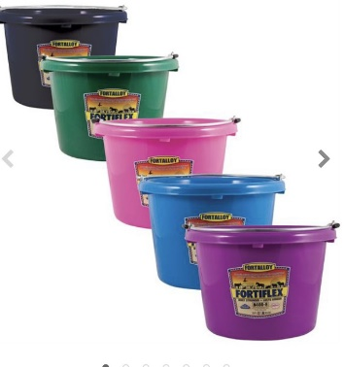
☐6 points  Choose an item.  Select Quantity  Equifuse Gleam | 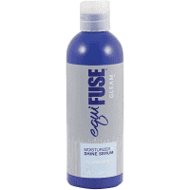

☐6 points  Choose an item.  Select Quantity  Award Lead Rope | 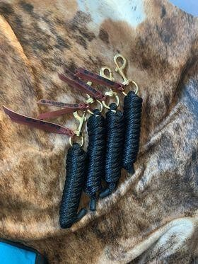
☐6 points  Choose an item.  Select Quantity  Bucket hangers | 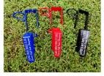
☐6 points Choose an item.  Select Quantity  Fan Holders | 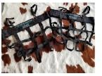
☐6 points Choose an item.  Select Quantity  Hay Bag | 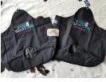
☐6 points Choose an item.  Select Quantity Bridle Bag | 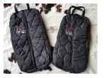
☐7 points Choose an item.  Select Quantity Award Water Bucket | 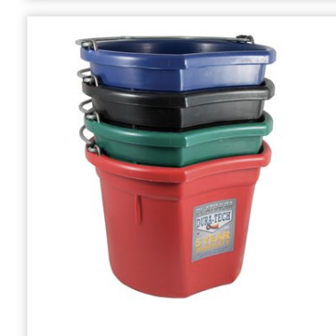
☐8 points  Choose an item.  Select Quantity  Crazy Cat Lady Small Book Bags | 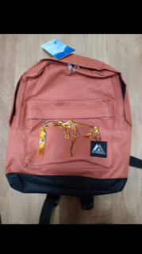

☐10 points Choose an item.  Select Quantity Basic Stall  Bags | 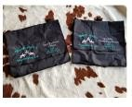
☐10 points Choose an item.  Select Quantity  Engraved  Tumblers | 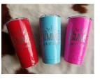
☐10 points Choose an item.  Select Quantity  Easy Tags | 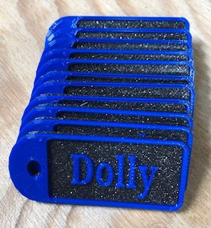 | Personalization:
☐10 points Choose an item.  Select Quantity  Award Pitch Fork | 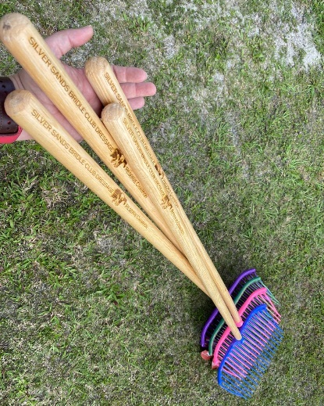
☐11 points Choose an item.  Select Quantity  Bluetooth Speaker | 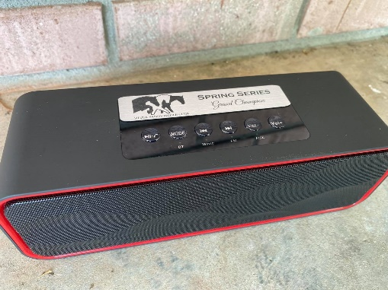
☐12 points Choose an item. Select Quantity  Bridle Racks | 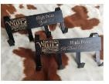
☐ 12 points Choose an item.  Select Quantity  Cush SHIN  Socks | 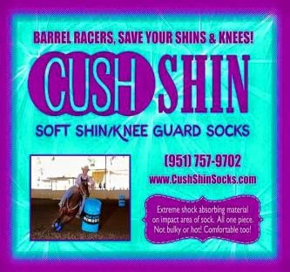 | *See Website for Color  Options  www.cushshinsocks.com
☐12 points Choose an item.  Select Quantity  ½ bale hay chix bags with Award Tag | 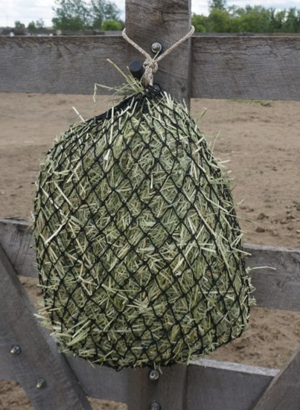
☐12 points Choose an item.  Select Quantity  Slow feed Hay Bag | 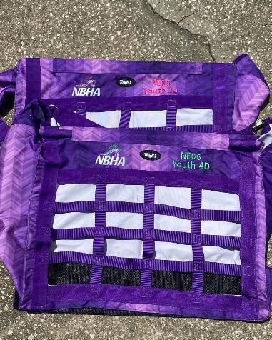 | Color:
☐12 points Choose an item.  Select Quantity  Benefab  Therapeutic  Smart Poll  Pad | 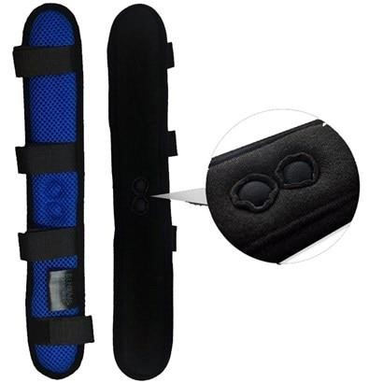 | NA

☐12 points Choose an item.  Select Quantity Cooler Pack Bag | 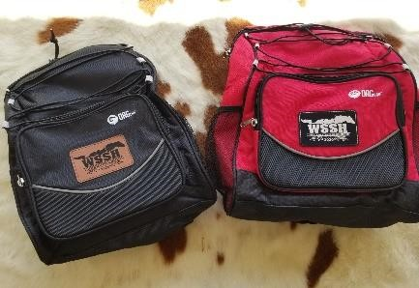
☐12 points Choose an item.  Select Quantity  DRAW IT  OUT  Gel (16 ounces) | 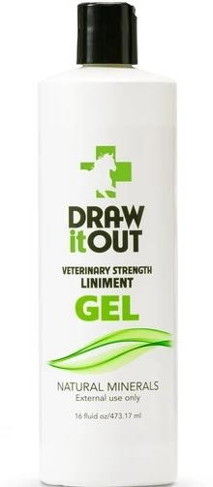
☐14 points Choose an item.  Select Quantity  Equifuse Bundle:  Shine and  Gleam | 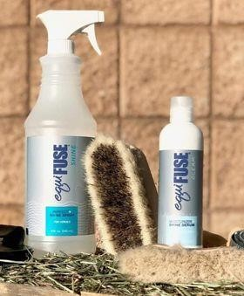
☐14 points Choose an item.  Select Quantity  Crazy Cat Lady Bookbag  (regular size) | 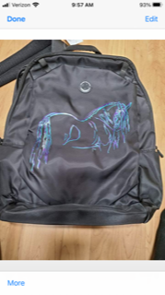 | Color Preference:  Personalization:
☐15 points Choose an item.  Select Quantity  FAHA 2021 Fleece Vest  Crazy Cat Lady | 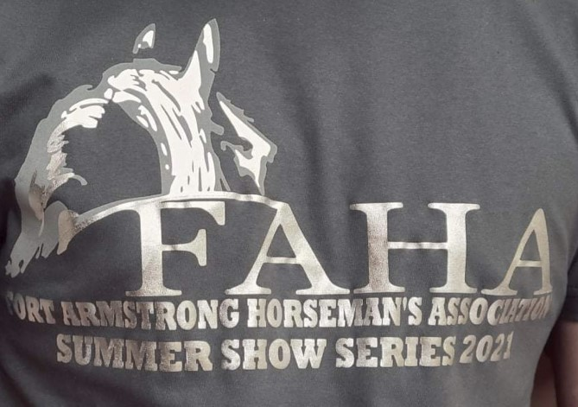Crazy Cat Lady Lazer Printed Vest  Colors: Wine, Black, Navy | Color Choice:  Size:
☐17 points  Choose an item.  Select Quantity  Engraved  Saddle Racks | 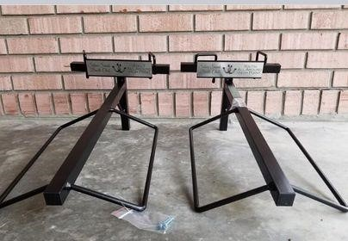
☐17 points Choose an item.  Select Quantity | GIFT CERTIFICATE:  HD EQUINE THERAPY  (option Magnawave or  Massage/Adjustment)

☐17 points Choose an item.  Select Quantity  Shoofly  Leggins | 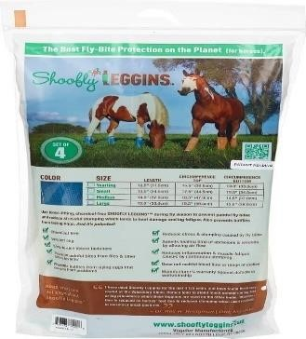 | ____PINK  ____BLUE  ____ORANGE  Size: _______
☐19 points Choose an item.  Select Quantity  Double K Leather Works:  Serape Wool Binder | 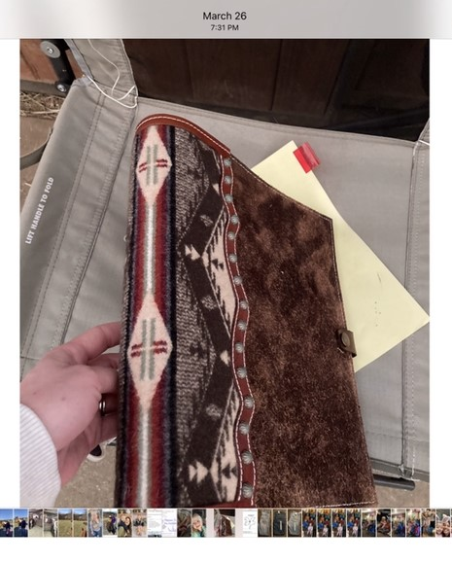 | Additional customization available.  Details will be discussed
☐19 points Choose an item.  Select Quantity  Double K Leather Works:  Wither  Strap | 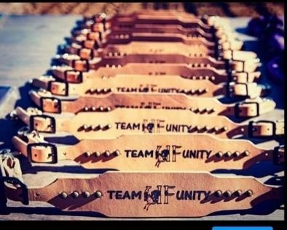 | Additional customization available.  Details will be discussed
☐20 points Choose an item.  Select Quantity  Award Muck Bucket and Cart | 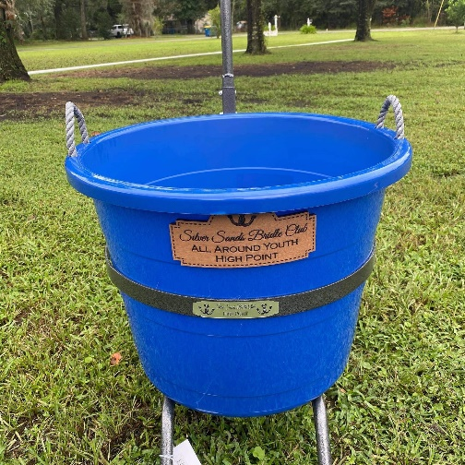
☐20 points Choose an item.  Select Quantity  Corral Caddy  2.0 | 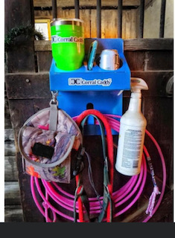
☐20 points Choose an item.  Select Quantity  Double K Leather Works:  Halter | 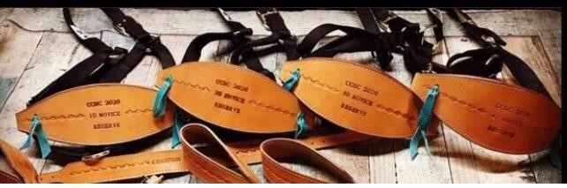 | Additional customization available.  Details will be discussed
☐20 points Choose an item.  Select Quantity  Crazy Cat Lady  Soft Shell Jacket | 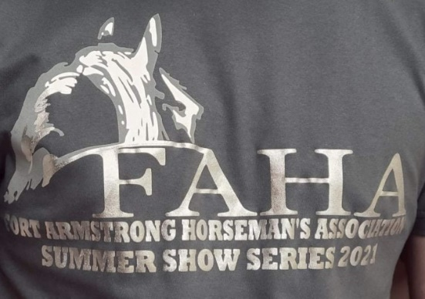 | Size:  Color:
☐22 points Choose an item.  Select Quantity  Double K  Leather Works:  Spur Straps | 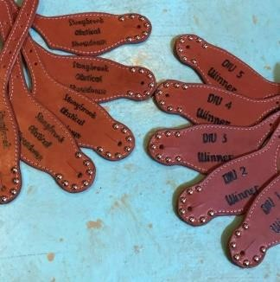 | Additional customization available.  Details will be discussed
☐ 22 points Choose an item.  Select Quantity  Fleece Cooler | 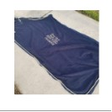

☐22 points  Choose an item.  Select Quantity  EquiFUSE Bundle | EquiFUSE Bundle:CFS Shampoo,  Rehydrinase Conditioner and  Gleam Serum  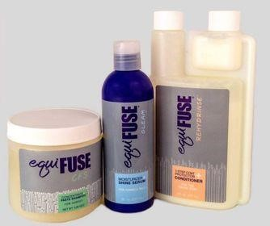 |  | NA
☐25 points Choose an item.  Select Quantity  Portable shelf  Engraved | 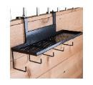
☐25 points Choose an item.  Select Quantity  Western Hat Can with engraved  leatherette piece | 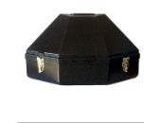
☐25 points Choose an item.  Select Quantity  Engraved  Step Ladder | 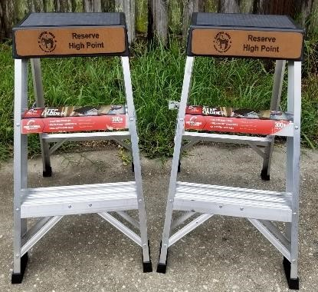

☐28 points  Choose an item.  Select Quantity  Corriente Award Knife | 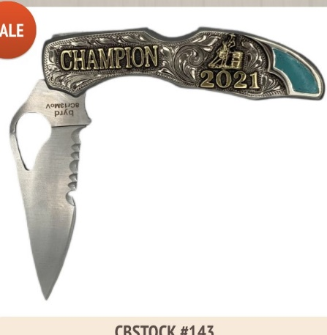
☐ 29 points Choose an item.  Select Quantity  Deluxe Stall  Bag | 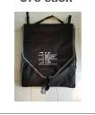
☐30 points Choose an item. Select Quantity  Fly Sheet | 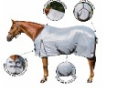 | Size:
☐32 points Choose an item.  Select Quantity  Show Cooler | 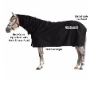 | Size:
☐34 points Choose an item.  Select Quantity  Draw It Out  Bundle  Liniment,  Concentrate,  Hat, and Spray bottle | 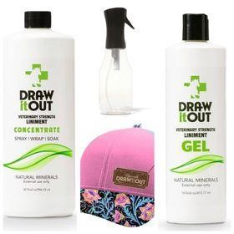

☐34 points Choose an item.  Select Quantity  Cowhide  Stools | 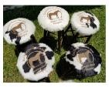
☐ 35 points Choose an item.  Select Quantity  Buckle  Molly’s Custom  Silver | 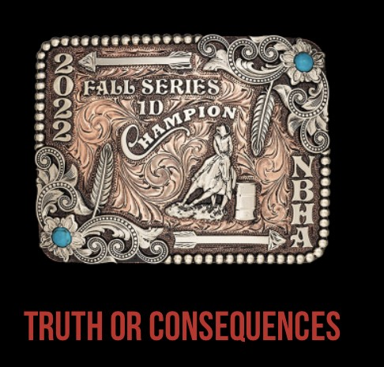  You choose the buckle under $100.00 ( you can do more and increase point value)
☐ 35 points Choose an item.  Select Quantity  Award  Troxel Helmet | 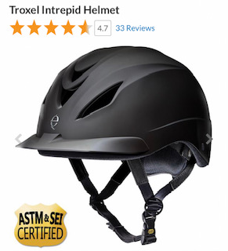 | Color:  Size:
☐ 37 points Choose an item.  Select Quantity  Double K  Leather  Works  Headstall | 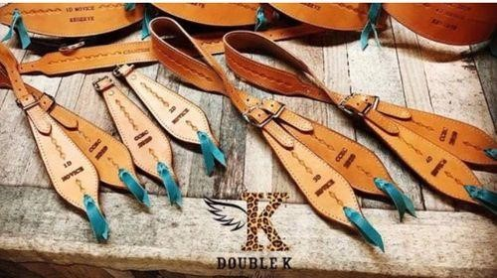 | Additional customization available.  Details will be discussed
☐ 40 points  Choose an item.  Select Quantity PHT  MagnaCu Fly Mask | 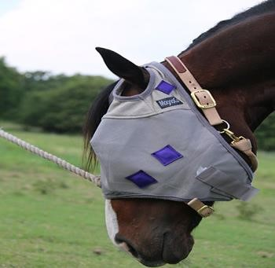

☐ 54 points Choose an item.  Select Quantity  Benefab  Therapeutic  Quick Wraps  Front or hind | 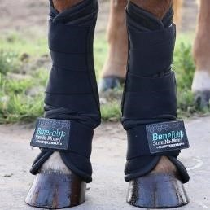
☐ 63 points Choose an item.  Select Quantity  Double K  Leather  Works  Breastcollar | 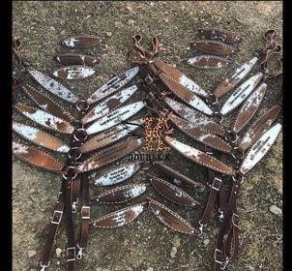 | Additional customization available.  Details will be discussed
☐ 110 points  Choose an item.  Select Quantity  Benefab  Rejuvenate  SmartScrim | 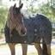 | Embroidery Option:  Size:
**If nothing offered meets your needs/wants please note what you would like as an award and we will try to find it. **

