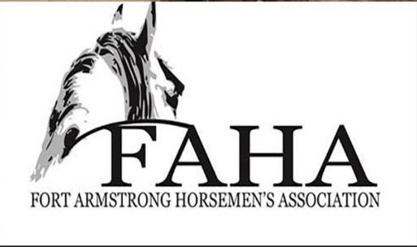

Fort Armstrong Horsemen’s Association
2021 Summer Series Sponsorship

Sponsor Name:_______________________________
Address:____________________________________
Phone Number:_______________________________
Website: ____________________________________
*Attach business card
Sponsorship Levels
*To be eligible for yearend awards Sponsorships must be paid*
- Individual Sponsorship: $30.00 Name: __________________________________
- Family Sponsorship: $50.00 Name: __________________________________
- Bronze - $125 – listing on our website and Facebook
- Barrel Wraps - $200 – to be displayed on our barrels during our events (9 available)
- Silver - $250- listing on a 2 x 3 banner displayed at park, advertisement on our website and on Facebook, and advertised on our shirts
If you get a Silver Sponsorship your personal sponsorship is WAIVED
- Gold- $500- listing on to our website, on Facebook, advertised on our shirts and a 3ft by 5ft banner for display at the park
- Platinum - $1000- listing on our website and on Facebook, advertised on our shirts and (1) 4ft by 6ft banner or (2) 3ft by 5ft banners for display at the Park
Sponsorships need to be paid by July 30th show weekend

