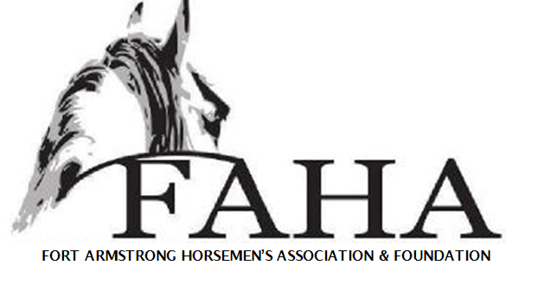
2021 Sponsorship Program
*Gift Certificate Donations or any amount is greatly appreciated*
- Bronze - $125 – listing on our website and Facebook
- Barrel Wraps - $200 – to be displayed on our barrels during our events (9 available)
- Silver - $250- listing on a 2 x 3 banner for display at the park , advertisement on our website and on Facebook, and advertised on our shirts
- Gold- $500- listing on to our website, on Facebook, advertised on our shirts and a 3ft by 5ft banner for display at the park
- Platinum - $1000- listing on our website, on Facebook, advertised on our shirts, and (1) 4ft by 6ft banner or (2) 3ft by 5ft banners for display at the Park
Banners will be displayed during the April-October 2021 Event Season. Website advertisement will remain through December 2021.
Name (or Company Name):
Contact:
Address:
City: State: Zip:
Phone:
Authorized Sponsor Signature:
Level of Sponsorship: _____$125 _____$200 _____$250 _____ $500 _____ $1000 _____ Other
Circle (Yes) or (No) to be added to our Sponsor List on our Website.
If donating $1000 or more, Please circle which option you would like (1) 4x6 OR (2) 3x5
Checks Payable to: FAHA Foundation Check #____________

Please send your checks to the address below and vector formatted logo to:
crookedcreekhorsepark@gmail.com
1588 Dime Road Vandergrift PA 15690
(724) 496 – 2114

